Wellbeing Hub in a Tub to support NHS Lothian community teams
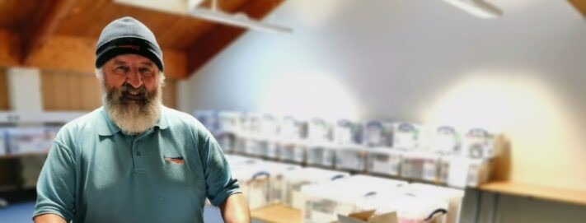
NHS Lothian and its official charity partner, Edinburgh and Lothians Health Foundation, recently worked together to prepare and deliver wellbeing boxes to NHS Lothian staff working in the community.
The pilot called ‘Wellbeing Hub in a Tub’, recognised that not all staff had access to the Wellbeing rooms that were set up across some of the hospital sites and needed alternative ways to access support to make a positive difference to their health and wellbeing during the Coronavirus pandemic.
The boxes included sleep packs, handcream, lip balm, energy snacks, refreshments, car chargers, headphones, and many other items to support the wellbeing of our teams in the community as they carry out their day to day role. They also contained a wellbeing booklet with advice and guidance on how to look after their own emotional and physical health during these challenging times.
Part of a wider staff wellbeing initiative, these boxes were made possible thanks to funding from Edinburgh and Lothians Health Foundation through its NHS Lothian COVID-19 Rapid Response Fund, collaboration with NHS Lothian teams, as well as through generous donations from companies including, British Airways, Friendly Soap, Doublebase, Cetraben, Hydromol, Diprobase, Epoderm KIND Snacks, RitterSport and BaxterStorey, with Network Rail supporting distribution.
Amanda Langsley, Associate Director of OD and Learning, who was spearheading the initiative, said: “It was really important for us to acknowledge the important role that all staff are playing during the pandemic and ensure that we were also supporting the wellbeing of our staff in the community. We have undertaken a lot of work setting up wellbeing rooms in various hospital sites and we needed to find a way to replicate this as best we could for staff who were unable to easily access these resources. 120 Wellbeing Hub in a Tub were distributed within the first week.”
Director of Edinburgh and Lothians Health Foundation, Jane Ferguson, said: “Improving health and wellbeing is at the core of everything we do. During this time, staff are under increased pressure and often put their own wellbeing second. That is why it is so important that while they are helping us, we help them. This is another fantastic example of everyone coming together to support our amazing NHS Lothian colleagues and we are proud to be part of it.”
Wellbeing Hub in a Tub is part of a range of staff wellbeing initiatives funded by Edinburgh and Lothians Health Foundation through their NHS Lothian COVID-19 Rapid Response Fund, including; supporting the provision of wellbeing rooms with recliner chairs, TVs and appliances so staff can rest, relax and get some much needed downtime, hot meals and drinks to keep staff nourished and refreshed during long and busy shifts, accommodation costs for staff who are self-isolating from their families, and an increased staff listening service offering support to NHS Lothian staff who are under extreme pressure during these challenging times.
As part of the publicity for this initiative, one of our staff members appeared on the Marks and Spencer website:
https://www.marksandspencer.com/c/style-and-living/how-you-helped-nhs-heroes

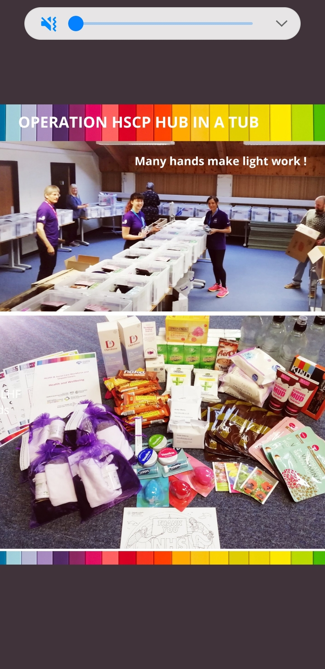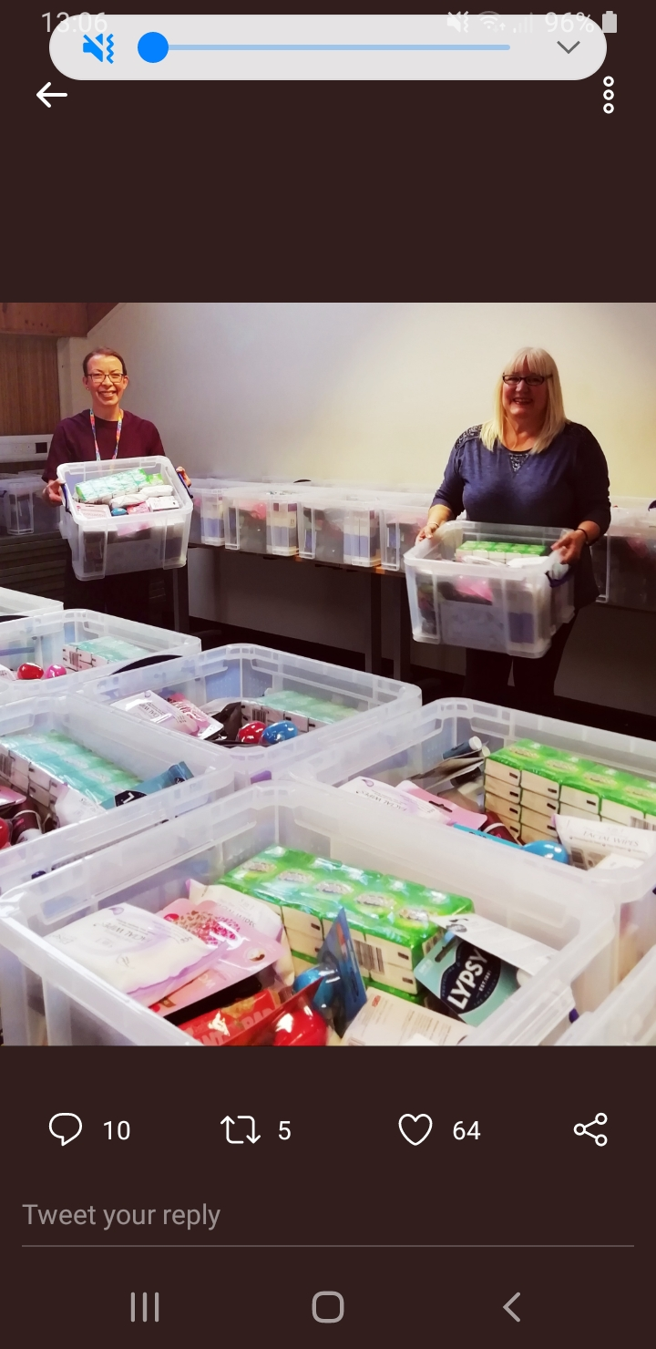

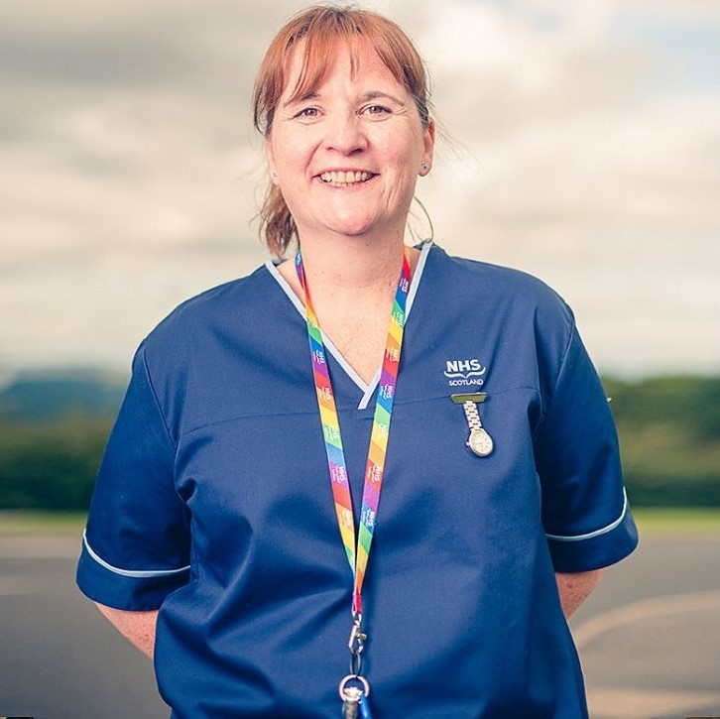

Mhairi-Jane is a specialist practitioner district nurse in Midlothian, Scotland. In May, her team received a “Wellbeing Hub in a Tub” filled with treats and practical items.
“As community nurses, we visit patients at home – we’re a ward without walls and build close relationships with patients and their families. When someone passes, we carry out a bereavement visit to see how the family is doing and give support. I went to see the wife of a patient who died in hospital. She hadn’t been able to visit because of Covid-19, and broke down. I comforted and reassured her but felt helpless. After hard days like that you really appreciate “Wellbeing Hub in a Tub”. Every item was so well considered: lavender face masks to ease anxiety, and snack bars to pop in the car in case we miss lunch. I took home a packet of seeds and now I have three flourishing basil plants. Pottering around getting lost in wee tasks, like growing herbs, helps me to relax and switch off.”
Mhairi-Jane is a specialist practitioner district nurse in Midlothian, Scotland. In May, her team received a “Wellbeing Hub in a Tub” filled with treats and practical items.
“As community nurses, we visit patients at home – we’re a ward without walls and build close relationships with patients and their families. When someone passes, we carry out a bereavement visit to see how the family is doing and give support. I went to see the wife of a patient who died in hospital. She hadn’t been able to visit because of Covid-19, and broke down. I comforted and reassured her but felt helpless. After hard days like that you really appreciate “Wellbeing Hub in a Tub”. Every item was so well considered: lavender face masks to ease anxiety, and snack bars to pop in the car in case we miss lunch. I took home a packet of seeds and now I have three flourishing basil plants. Pottering around getting lost in wee tasks, like growing herbs, helps me to relax and switch off.”

