Wellbeing Space for Staff – Physio Team Fitness Classes
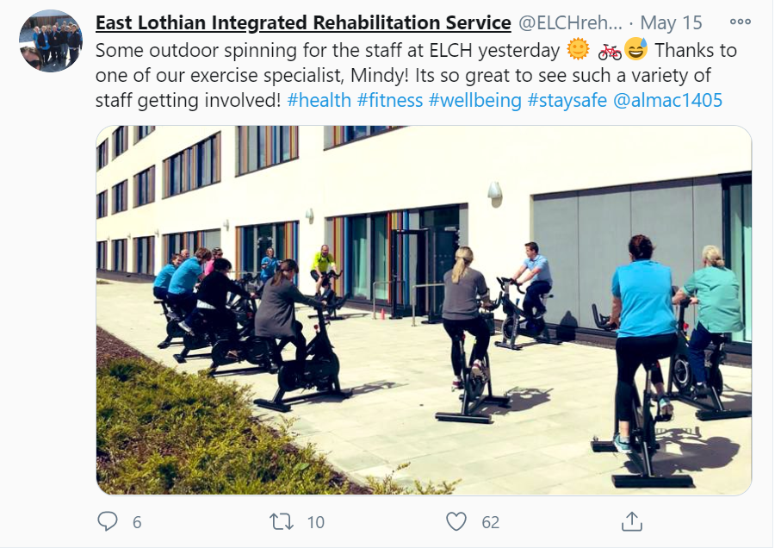
The Physio Team in East Lothian organised fitness classes for staff including Lunch Circuits and Tai Chi available at any time on the links below. Plus twice weekly Tai Chi and daily exercise classes delivered by the great physio team along with outdoor spinning classes and riverside walks in between patient contacts.
Lunch Circuits class link
https://web.microsoftstream.com/video/7a609767-9f78-4545-a08e-58075d4e3966
Tai Chi Lunch Session
https://web.microsoftstream.com/video/da4f9f46-956c-48ca-a9c3-c689d4f0e51e
