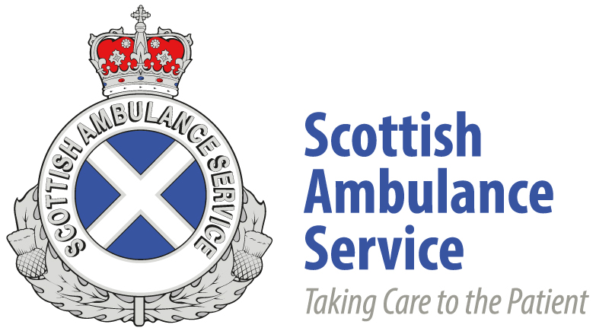

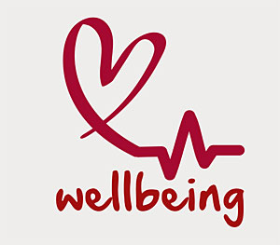

The SAS Bloggers

**The Team**

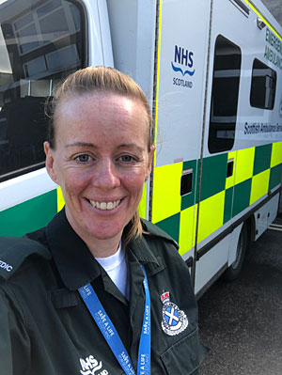 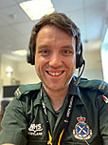 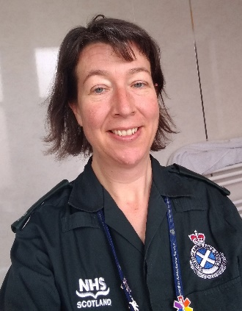

Keri Fickling Darren Miller Jessica Flett

 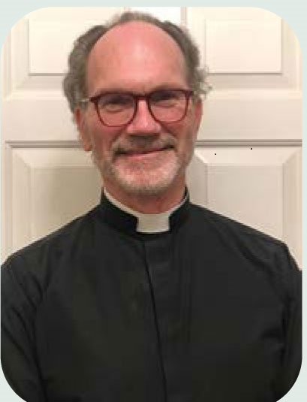

Dan Farnworth Chaplain – Deacon Michael Ross

**Our Story**

We are five individuals who have come together virtually through a shared passion for improving staff health & wellbeing and supporting our colleagues in the Service. It all began when Dan volunteered to start a wellbeing blog with the aim of engaging others in the Service to start a conversation about wellbeing. His blog was written from the heart, sharing his personal experiences with both humility and humour that resonated with us and our everyday work in the Scottish Ambulance Service. We were inspired to contribute ourselves and one by one we joined and formed a small and enthusiastic team called ‘The SAS Bloggers’.

**Creating a wellbeing blog by staff, for staff**

We started the blog around the time that the COVID-19 pandemic started to make an impact when our organisation was looking at different ways we could support our staff and it has provided us with plenty of wellbeing topics to write about. What has worked well is that we all have different styles of writing, varied backgrounds and experience so each blog gives a different perspective on each topic. A wellbeing blog is posted every week with a different topic each time. We have covered topics from mental health, being human, social connections and managing guilt to exercising when you hate it, the importance of sleep, balancing life & work and managing uncertainty, to name a few.

**Has it made an impact?**

More staff have accessed the wellbeing blog than any other wellbeing resource provided internally or externally since it began in March 2020. That has made us very proud to be part of this team and we are keen to continue writing and developing the blog.

Here is what some of our colleagues have said:

Really helpful insight into how we are feeling and the need to be kind to ourselves and to each other

This really struck a chord with me. It has highlighted that I can still teach my children valuable life lessons even when I’m not there and I need to remember that I’m not being selfish putting myself first once in a while. I can only care for others when I care for myself.

I’m so thankful for this blog. It has reminded me to check in with myself, my partner and other parents.

That is such an insightful look at stuff!! Such a wonderful piece of writing!!

It was such a breath of fresh air to hear such honesty. I’ve struggled with binge eating for most of my adult life and I can’t thank her enough for this brilliant piece.

The blog has not only benefited our colleagues – it has helped us too!

I am proud of the work of all the team in the well-being blog. While I have had my own challenges, I have found the outlet of writing helped me immensely, but not only that, to have colleagues actively approach me and thank me for my efforts and how it has positively impacted them has made this incredibly worthwhile.

Darren Miller

I think the blog is a good way to start breaking down the barriers we have about wellbeing, and providing a space where staff can share what’s going on for them, as well as learn about wellbeing.

Jessica Tett