Employee Voices

District Nursing
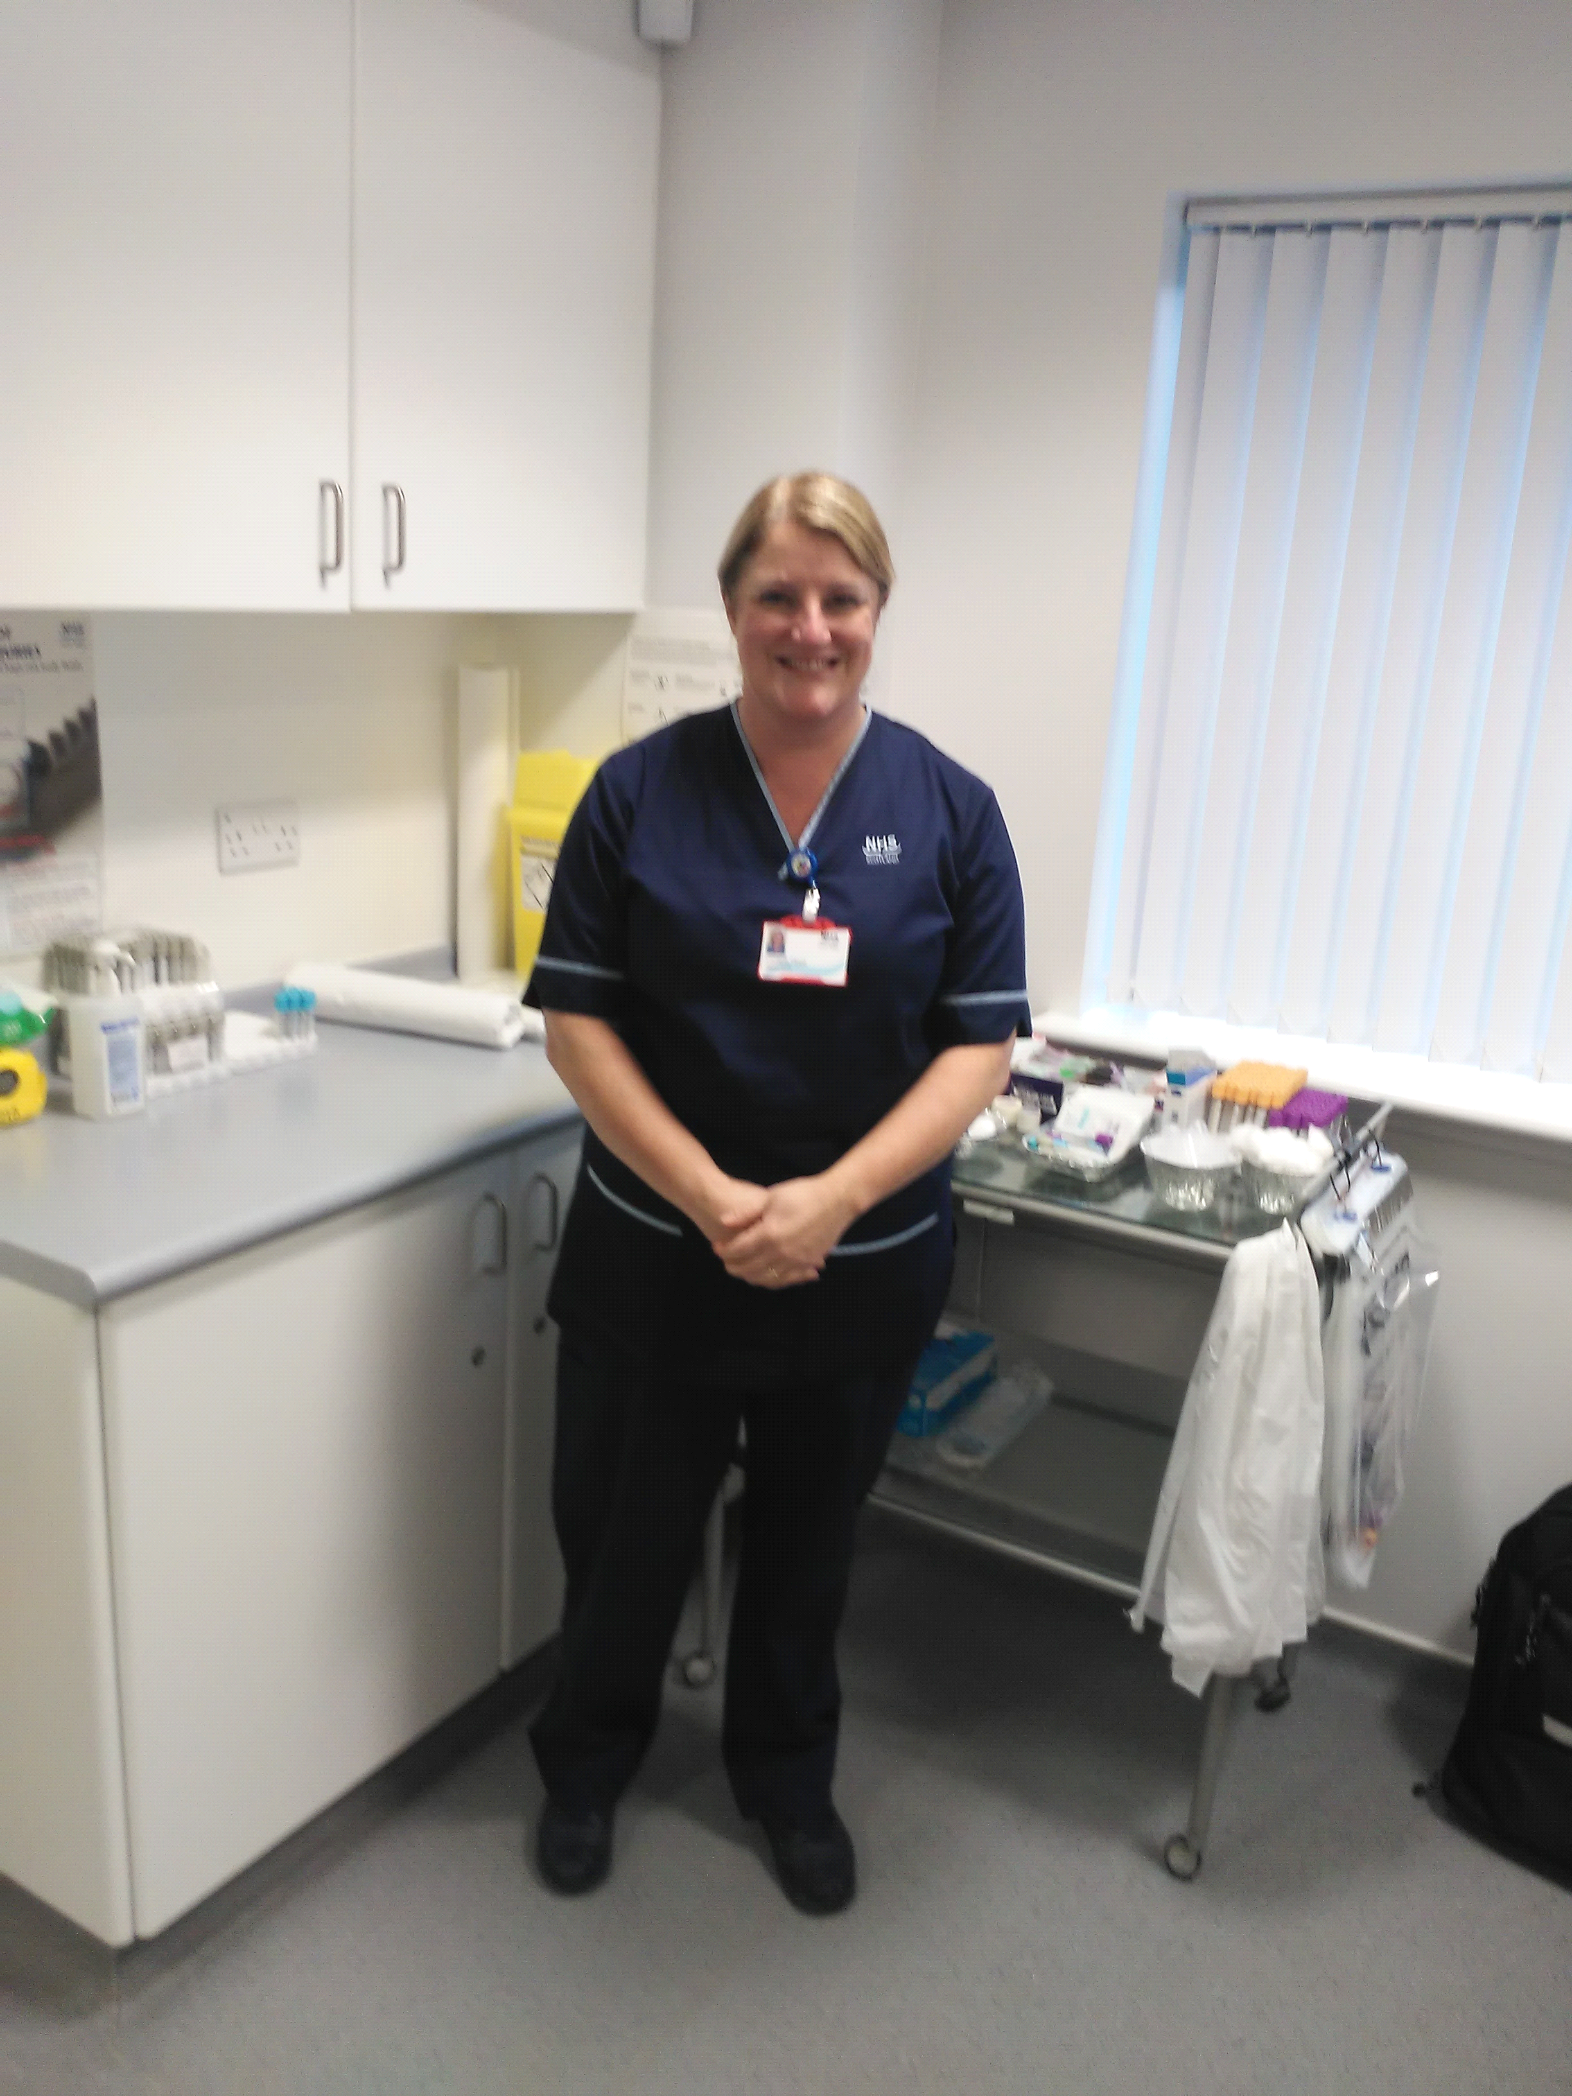

When I first heard of Coronavirus through the media, I didn’t pay too much attention to it. I viewed it as something that was far away and would not affect me directly. As cases increased and spread throughout the world my view changed very quickly. At the start of the Pandemic I felt that there was a lot of uncertainty and anxiety. Personally this was in relation to keeping myself, and my family safe, whilst also being able to provide care to our most vulnerable patients in their own homes at a very difficult time. I was in a fortunate position that my husband and I both were able to continue working throughout and did not have to worry financially but I know that this is not the case for many others. Also working full time with 2 children in high school, I was concerned that I wasn’t able to provide enough support to them to continue their education from home.
Initially there was difficulty in accessing appropriate PPE and conflicting advice on its appropriate use. Once this was available and we were given clear instructions of what PPE should be used in different situations I felt that levels of anxiety reduced. Patients were encouraged to self-manage their condition where appropriate and were provided with education and support to enable this. We also encouraged family members to provide care to their loved ones where appropriate and a lot of support which would have normally been provided face to face was given over the telephone. This was possible for some of our patients but there was still a vast amount of our caseload who continued to need face to face visits especially when providing palliative and end of life care. All face to face meetings were cancelled and transferred to a virtual platform. Social distancing was implemented on office areas which posed a challenge due to office space and staff numbers. At first this felt very strange, however as things have progressed this has become our new normal and the initial feelings of anxiety have reduced and our working practices have continued to evolve to meet the changing needs.
I feel that a positive to come out of this is that it has enhanced team working within individual and the wider teams. The daily virtual meeting allows areas which require support to be identified and resources managed effectively. As things move forward I think that this new way of working has become our new normal and as nurses we will continue to strive to safe and effective care and support to all our patients in adverse circumstances.

