Employee Voices

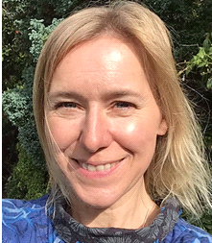

Sarah Dove, an Occupational Therapist, has captured her experience of working in the Bellfield Centre, earlier this year in verse.

Deployment 2020
Armed with compassion we went as a team
To assist in the war against Covid-19.
Adrenaline, professionalism (and cake) fuelled
We realised quickly the virus was cruel.

Patients had no visitors.
Patients saw no smiles.
Television vomited anxiety,
Patients were worried, so were we.

Donning, doffing PPE…..donning, doffing PPE!
A daughter on the phone was reassured to know her Mum had her slippers on to
keep her warm.
She cried and asked me to -
“please, please keep her from harm”.

But names on the ward were turning red,
Colleagues were at home, sick in bed.
Numbers were rising every day, we struggled with ways to cope.
Isolation, separation…..challenges to hope.

‘Kind hearted, beautiful beings’…essentials on job recipe.
In it together, we knew the score….my colleagues and I family.
One stayed late to play piano.
One gave us seedlings to grow.
Our internal angst was expressed by one, who let all emotions show.
We listened, supported and we laughed…..
We definitely needed to laugh.

I made some badges, pinned to our aprons, our faces showing a smile.
A real smiley face, in real life….. maybe quite a while.

My family stayed at home whilst I drove car free roads to work.
Home schooling was done, Zoom zoomed, sunny weather was a perk!
I willed the police to stop me, for breaking lockdown rules.
Who ever thought that working for the NHS would ever be kind of cool?

In March when this all started, the geese were migrating away.
Now they are returning, for winter they will stay.
Next time we say Goodbye to geese, let’s hope there are no bugs.
Instead, that we can celebrate and give our loved ones hugs.

