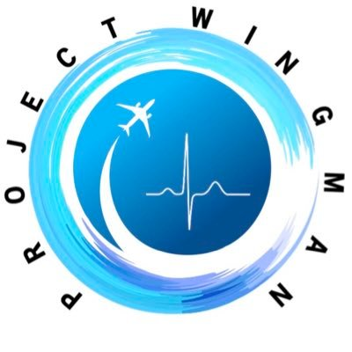

**When a smile, a cuppa and a space to breathe is just what’s needed**

Airline crew from throughout the industry came together to support the wellbeing of frontline NHS staff throughout the UK during the Covid-19 outbreak. During the peak of the outbreak the Wingman Project opened lounges for NHS Lothian staff in the Royal Infirmary of Edinburgh, the Royal Hospital for Young People, Royal Edinburgh Hospital and St Johns Hospital, Livingston.

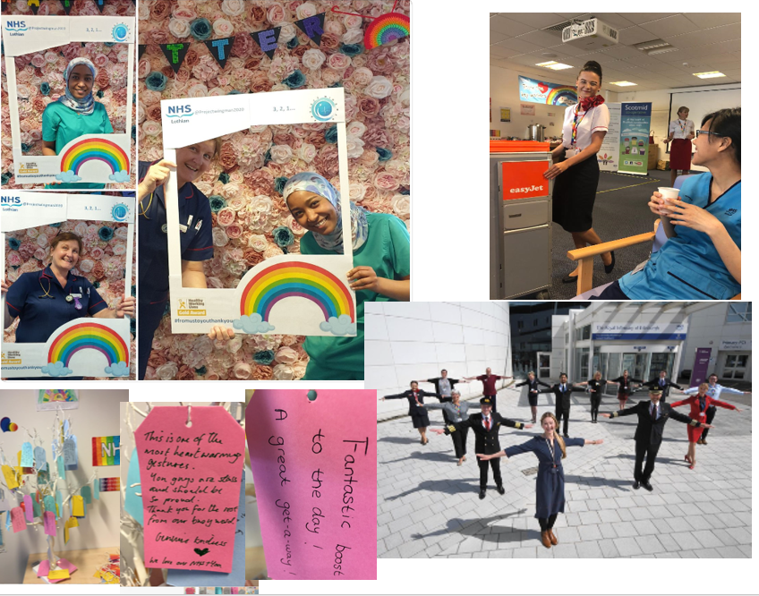

The Wingman Project – Our Mission  
*Project Wingman is a group of current and former aircrew from all corners of aviation, United by our profession and dedicated to serving our NHS staff now and in the future. We provide space to unwind, de-compress and de-stress before, during and after hospital shifts, in support of staff wellbeing.   
  
Since NHS workers give first class treatment to their patients, our ‘First Class Lounges’ are our way of giving NHS staff the treatment they deserve.  
  
Furloughed, grounded, or made redundant by the COVID-19 crisis, we aircrew find ourselves in the unexpected circumstances of having the skills and time to help those most in need of a smile.  
  
Crew are all trained in human factors and how to communicate with colleagues who are in stressful situations. We fellow uniformed professionals understand what it is like to operate in a highly disciplined, regulated and pressured environment.   
  
This goes a long way in bonding and shared experience and empathy. Medical staff need to talk about their job with people who can empathise with the pressures involved.   
  
Whether it’s talking to a cabin crew member about their travels or being handed a cup of tea by a pilot, our uniformed and dedicated airline crew are putting smiles on the faces of NHS workers across the country.*