NHS Voices in a time of crisis - Maria’s Story

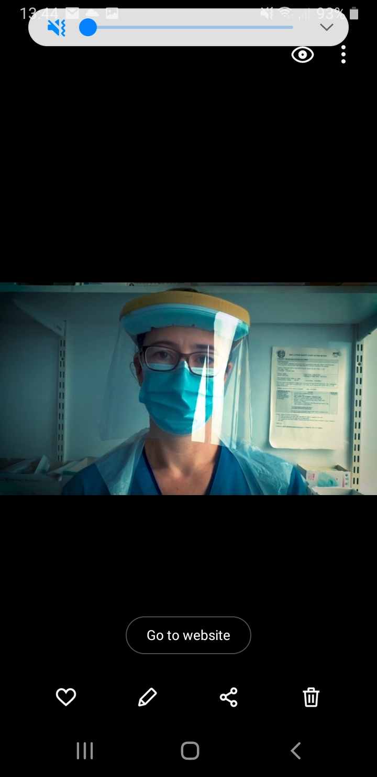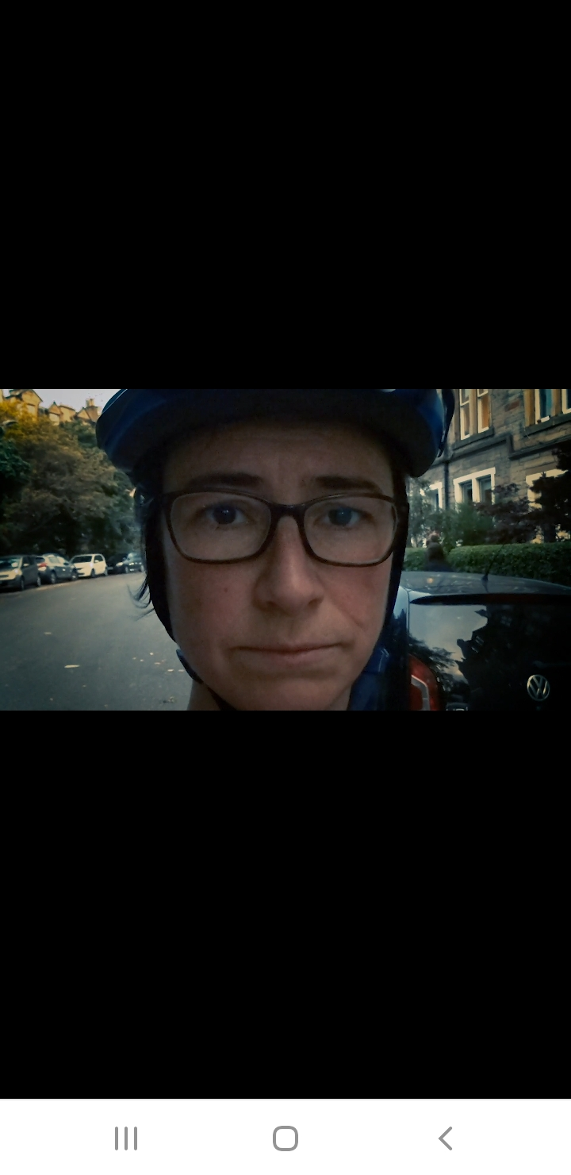

Maria Gonzalez’s Story - <https://vimeo.com/467638789>

*Maria is a Staff Nurse at Edinburgh’s Western General Hospital Cancer Treatment Centre.*

*She still enjoys cycling to and from work.*