The State Hospital Person Centred Improvement Team i-Matter Story
Building Thoughts: Connecting Blocks
The State Hospital’s Person Centred Improvement Team of four, is small in size however big in impact!
Team members have remained static since 2017 with the outcome of all i-Matter indicators within the ‘My Team / My Direct Line Manager’ section achieving 100% for the last 3 cycles.
Indicator levels relating to the majority of the other sections: ‘Staff Governance’, ‘Experience as an Individual’ and ‘My Organisation’ have scored fairly consistently since the initial cycle in 2015.
These outcomes present a real challenge in terms of motivating the team to engage year on year:
“Feels like a tick-box we’re having to think about how we could improve things when we’re happy with the way the team works.”
“We’re too busy to be taking time out to do something we don’t feel is of any value.”
“What’s the point? It just tells us the same thing every year”.

It would be easy to become complacent when looking at the data – we function well as a team, care about each other, listen to and respect each other’s opinions and get the job done.
We discussed how to maintain a positive approach to engaging in this year’s cycle and agreed to test the creative feedback model, the team used in this year’s ‘What Matters to You?’ initiative, to support patients who find it difficult to share their views. This approach enabled team members to think about providing feedback from a different perspective:
“I’m stuck behind my PC and can’t do what I really want to do to develop my role. I’ve got lots of ideas which I’d like to be able to mature and grow but I can’t get away from all the paperwork.”
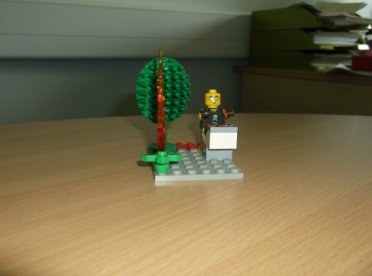
Team members agreed that adopting this model was a helpful way to overcome some of the perceived barriers to continued engagement in the i-Matter process. Outcomes emerging from this creative feedback process supported everyone to contribute meaningfully to development of this year’s Action Plan.
Significantly, the translation of models to words highlighted many positive aspects relating to team cohesion and understanding more about why the team functions so well.

