The Forth Valley Way
Cathie Cowan, NHS Forth Valley Chief Executive, was barely in post when the first organisation wide distribution of iMatter commenced in early 2018. As an iMatter champion in her previous Board, NHS Orkney, Cathie was keen to put the same level of support and energy into iMatter in NHS Forth Valley. This started with an article in our Staff News and has continued throughout the current iMatter distribution cycle. See below Cathie’s Executive Team.
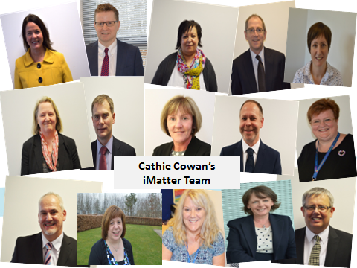

Cathie has modelled the iMatter Continuous Improvement Cycle by encouraging her own team, as well as all others across the organisation, to participate fully in iMatter and has promoted the benefits of doing so. Her ‘Chief Executive Officer’s Team’ met to review their iMatter Team Report and create an agreed Action Plan. Cathie’s team did a comparison of their results with those of the overall organisation, clearly highlighted opportunities for improvement and committed via their iMatter Action Plan to doing the following:
- Improving visibility of senior management
- Empowering staff to become more involved in decisions which affect them
- Building confidence and trust in senior managers
The team story is told in pictures, beginning with comparing the team component scores with those of the wider organisation and moving on to bringing the Action Plan to life by conducting a range of Staff Engagement sessions. As a result of having the support from all of the Executive Team, NHS Forth Valley went on to have a very encouraging first whole organisation roll out of iMatter, and with a significant increase in the percentage of teams meeting to discuss, agree and record Action Plans we achieved a completion rate 80% – this is what Cathie calls “The Forth Valley Way.”

