Maternity and Children Quality Improvement Collaborative (MCQIC) – imatter team story
Heads were down. There were uncomfortable silences and glaring looks. Even a fly on the wall would have felt awkward at the MCQIC imatter discussion in November 2017. Clearly, there was room for improvement.
We identified two main areas that we could improve as a team: communication and relationships. These were big, daunting issues to tackle, but by creating our imatter action plan we were able to break it down and map out some of our solutions.
Specifically, we agreed to continuously review the format of our weekly huddle to help improve clarity on team priorities and weekly activity and improve our understanding of each other’s roles and responsibilities. We also scheduled monthly project team meetings after programme delivery meetings so that all team members would be aware of higher-level team activity. And we agreed to dedicate some time to getting to know each other on a more personal basis – such as having lunch together before a team meeting.
A key action to help improve both relationships and communication was embarking on a series of team coaching sessions with Catriona Macmillan, Organisational Learning and Development Advisor. These sessions helped break down barriers to communication and allowed us to talk through and find solutions to some of our issues.
We all put in effort and bravery as individuals to improve our team relationships, stepping outside our comfort zone both at the coaching sessions and in day-to-day work. We worked together as a team to create and perform a Christmas ‘wrap’ at our December unit team meeting – it was embarrassing and nerve-racking, but it was fun and, importantly, we were all in it together.
Fast forward to our next imatter discussion in August 2018. The room was full of lively discussion and laughter, and team members were comfortably voicing opinions. We had moved towards a genuine appreciation and understanding of each other. We also noticed the positive impact this seems to have had on our team’s effectiveness and efficiency. We recognised and celebrated the great progress we had made as a team, but there was still work to be done – and the continual imatter process supported us yet again to map out our plan for improvement and the specific actions to help us achieve this.
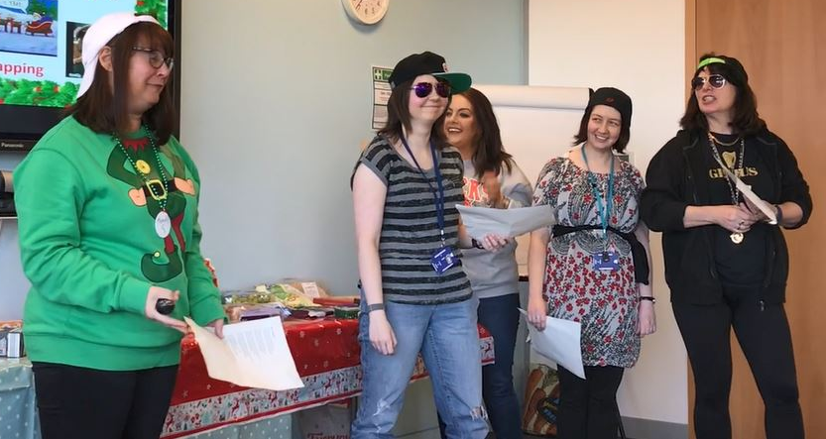
Members of the ‘M.C. QIC’ team performing our Christmas ‘wrap’.

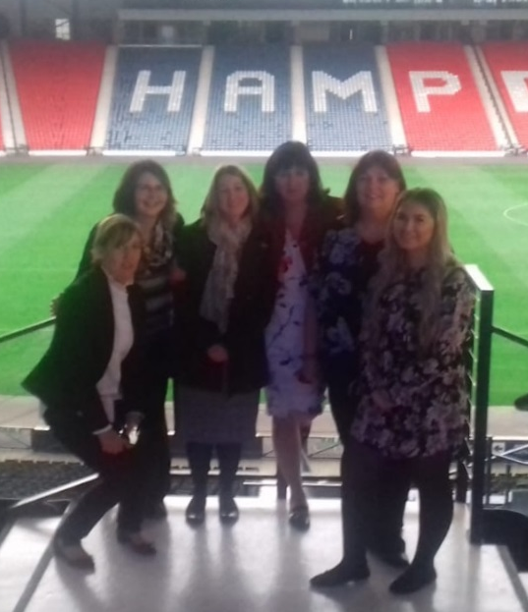
The winning team at our networking event in Hampden in October 2018.

