Children & Young People’s Occupational Therapy Service
Our iMatter Story
“ it is important we are asked what matters to us “ Aileen McFarlane, OT

“it contributes to us feeling valued” Fiona Mudie, OT

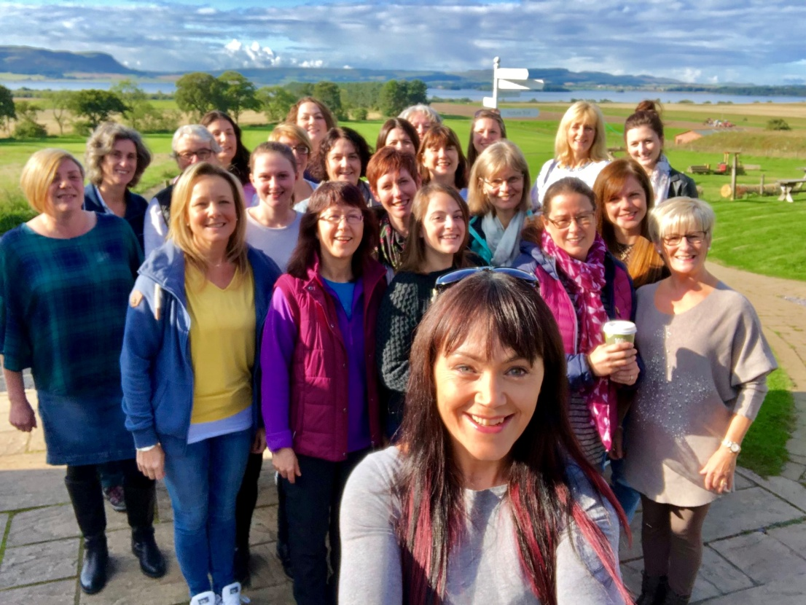
“it is great to celebrate what we do well and to be clear about what we could do better” Hazel Golon, OT

“it reinforces that it is everyone’s responsibility to support and maintain a positive working culture and relationships” Ruth Johnston, Lead OT

“We matter ... we make a difference”
The Children & Young People’s Occupational Therapy Service is Fife wide. We are an integrated health & social care team, based in 4 geographical locations (North, East, Central and West). Due to clinical pressures, geography and travel time it is not possible to physically meet as a whole service beyond set clinical governance events which happen 3 times a year. However, we work closely with each other and other teams across Fife using Lync – video conferencing communicator.
Benefits of Lync
- Protects clinical time
- Reduced travel / carbon footprint
- Improves communication and opportunities
- Allows you to see the person
- Clinical observations
- Sharing of documents
- Facilitates training
- Meetings, Supervision, peer review, collaboration on projects

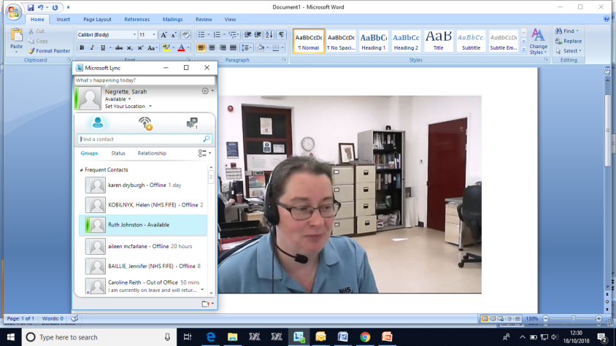
OUR 6 STEP iMATTER PROCESS:
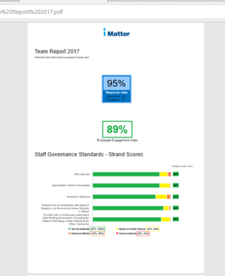
- iMatter report: We agreed as a service that the imatter report
would be discussed locally in each base framed around the below
questions;
- What is the report telling us ?
- What should we celebrate and continue to do?
- Agree one area of strength and success
- Identify areas which we would like to improve

- Meeting: A representative from each base then participates in a collaborative meeting with line manager to share local discussion, reflections and thoughts. Lync is used to support this meeting and protect clinical time by avoiding travel.

- Reflection: There is opportunity to reflect on previous iMatter report and action plan. For learning and assurance purposes

- Action Plan: During the meeting an action plan is co-produced and shared with the Fife wide team for comment and agreement.

- Impact and improvement: The action plan is kept ‘live’ and progressed in various service forums.

- Shared ownership - Emphasis is placed on shared ownership of the action plan across the service and actions are escalated where appropriate

Key Points:
- iMatter makes a positive contribution to our quality improvement journey
- iMatter priorities staff engagement. The wellbeing of our workforce is the foundation to what we can achieve and the help and support we can offer to communities.
- Celebrating what we do well is a real boost
- Being clear about desired outcomes -‘ what this will look and feel like’

