Staff views: they Matter to us!
Our IMatter component report’s lowest scores were in relation to staff experience of the HSCP. Some of our staff that had attended IMatter sessions pre-survey had noted that the Organisation scores had been the lowest scores in our component reports in 2016 and 2017, and asked about how they could possibly influence HSCP level improvement. As a senior management team we reflected on the fact that there is no function within the IMatter system for uploading Organisational actions and deliberated on what we should do. At the same time we were discussing how to support action planning across the HSCP and had set an ambitious target of 80% completion.
We therefore decided to draw up an action plan that aimed to improve our staff’s experience of senior managers being sufficiently visible and feeling involved in decisions relating to the organisation from 68% and 62% respectively.
To increase senior manager visibility we have commenced a schedule of service area visits to increase visibility and provide opportunities to meet and speak to staff across the HSCP. Chief Executive visits were planned to service areas. As Heads of Services we are out and about connecting with our staff and engaging in generative discussion, and learning from each other. Aubrey Fawcett (CE, Inverclyde Council) has visited our Addictions services and Learning Disability services, and recently attended our Staff awards. Louise Long (CO, Inverclyde HSCP) has regularly visited services talking to frontline staff and learning what’s important to them. Jane Grant (CE, NHS GGC) is planning to visit Inverclyde in the near future. Being “seen” is only part of the aim to have a workforce who experiences the HSCP as great place to work. Being in contact with our staff encourages learning and provides opportunities to positively influence how we all work together by building relationships and modelling the values of the HSCP.
We are in the process of producing an HSCP induction film for all new starts to hear about the HSCP values and how we work together from their senior managers and professional leads. This is followed up by a face to face meeting with the Chief Officer, Chief Social Worker or Lead Nurse within six months of their employment commencing.
We have adopted an inclusive approach to learning and development, for example our upcoming leadership development workshops “Better Conversations” include leaders and managers from across the HSCP all learning, reflecting and practicing new skills together. This provides opportunities to build relationships and increase visibility.
In order to provide more opportunities for our staff to feel involved and share their views, all our redesign programmes within the Transformation Board include staff work streams. Some of the work streams are led by staff groups for example the review of Occupational Therapy.
We have created two “open chairs” for staff members to attend the Staff Partnership Forum, in addition to encouraging staff to speak to their Union Representatives to have views brought to the Forum. As a senior team we are reflective and work together to hear what’s important to our staff. We are currently co-creating our Strategic Plan with our staff through a staff survey, focus groups to explore our values, vision and priorities, and targeted discussions with groups whose views are traditionally not heard, for example homecare staff and residential care home staff.
This year we achieved an 84% return on our action plans which was a huge achievement. The general feedback is that our staff appreciate our visibility and engagement. When we ask our staff for their views, they are engaging in conversations and we’re listening. We don’t always get it right 1st time but we’re always learning and reflecting on better approaches!
IMatter isn’t the panacea, however is a good indicator, a snapshot of how staff are feeling each year and allows us to plan and assess our continuous improvement journey. This year we had an 81% increase in staff award nominations and 115 staff attended and had a great time, even those who said they felt a bit cynical about “awards”. We are aiming to build on our positive core and this year hope to get our 1st ever HSCP specific iMatter report.
We are enthusiastic about Inverclyde HSCP and our wonderful staff; spending more time and learning from and with them is both humbling and inspirational. IMatter has helped us focus on what is important to our staff and by focusing on this improvement journey we trust they will know that they matter, we all matter.
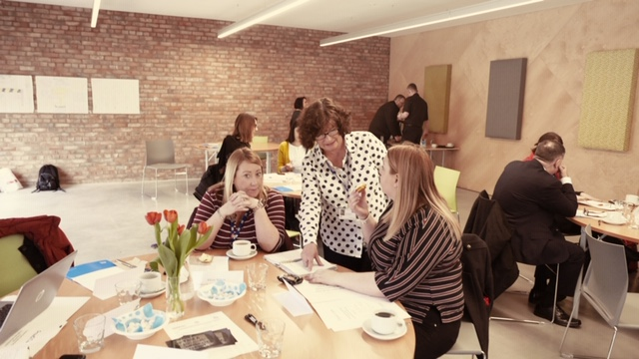
Sharon McAlees, Head of Children Services and Criminal Justice and Chief Social Work Officer at a 3rd sector and staff event.

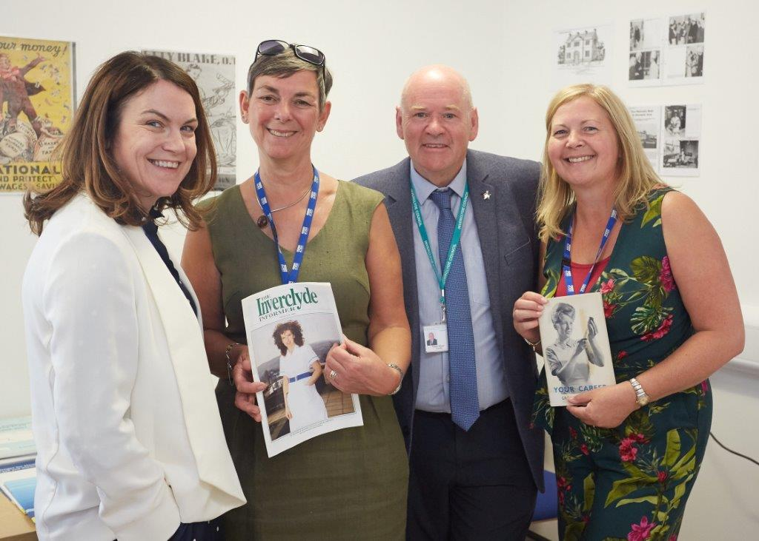
Louise Long (Chief Officer) with Deborah Gillespie, Head of Mental Health, Addictions and Homelessness, Councillor Robert Moran and Carol Fitzharris (Service Manager, Mental Health) at our NHS 70th celebration at Orchard View

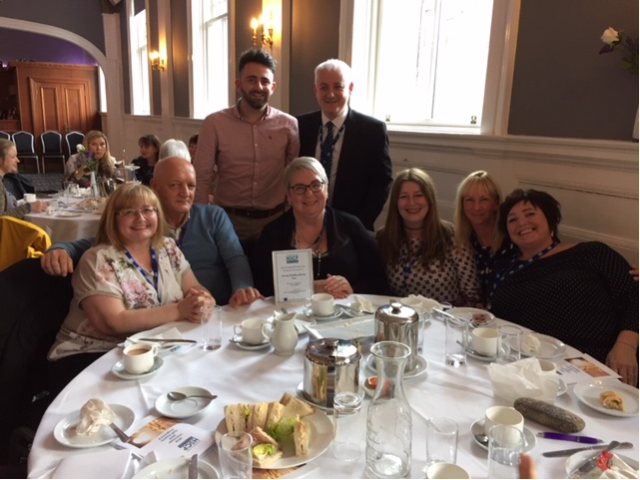
Allen Stevenson, Head of Health and Community Care with the LD Redesign Team at our 2018 Staff Awards

