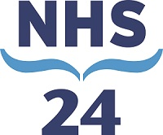
NHS 24's Health Information Services Team - A Fishy Tale...
NHS 24's Health Information Services (HIS) department consists of three teams, with three different managers and all of whom are geographically split across two centres – Clydebank and Aberdeen.

Background

Our iMatter journey began in 2015. Feedback from each of the three teams had similar themes – so we decided that the best way forward was to work closer together on the themes that we all had as common ground. While there was still a requirement to have three separate iMatter questionnaires, we agreed to do a joint action plan. We took the response rate and the Employee Engagement Index from the three questionnaires, and worked out the average to produce these joint figures:

- Response rate across the three teams - 84%
- Employee Engagement Index - 77%

A representative was nominated from each individual team to gather comments and discuss actions. These were brought to a larger meeting with management representation to facilitate. From there, our joint actions were decided and our storyboard made.

Areas of improvement agreed as key priorities across all teams:

1. Improved communications regarding matters affecting staff
2. Improved visibility of senior management team
3. Agreed use of current and new processes to improve transparency and consistency.

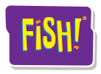
What We Did

First, we agreed to engage with FISH PHILOSOPHY that focuses on:

- ENGAGEMENT AND MORALE
- CUSTOMER SERVICE
- TEAMWORK AND TRUST
- RETENTION AND RECRUITMENT

Sessions were organised for everyone and we had great buy in from our team!

What We Achieved

Communications | - Any changes to day to day operations now communicated in advance and rationale given for the changes.  - Staff now participating at broader decision making meetings
Visibility | - Senior managers now come in and speak with team when in the centres.  - Management and team photos are now on our notice board, and efforts are being made by everyone to MINGLE.  - Whiteboards in centre for any breaking news!
Transparency and consistency | - More centralisation of call review audits and staff training to produce more consistent feedback and results  - Guidance document for using e-KSF produced for uniformity across teams.  - Page One system( text contact with staff) and emails sent at the same time to make sure staff on and off shift have the same opportunity to receive the same message at the same time- eg offer of additional hours , shift swaps, etc.  - Staff invited to feedback through survey monkey , Regional Partnership Forum and/or via meetings with line managers on how best to resource service demands during the busy periods
What we are doing now to keep this going

- Monthly team brief- news, views and stories, both business and pleasure, created for the team by the team.

- Development Coach role created - allowing a team member to take responsibility for asking the team what training they feel they need and arranging for it to be delivered with the intention of improving staff knowledge of the services we provide.

- Themed months- Champions selected for topic areas that our service delivers. This involves knowledge updates and reminders to the team from the champion; reinforced through quizzes (sometimes with prizes) and fun topical facts.

- New updated holiday process put in place – this demonstrates transparency and evidences that management are listening to staff concerns and acting on them to improve morale.

What we are still to do?

Team building days and of course our next iMatter session!

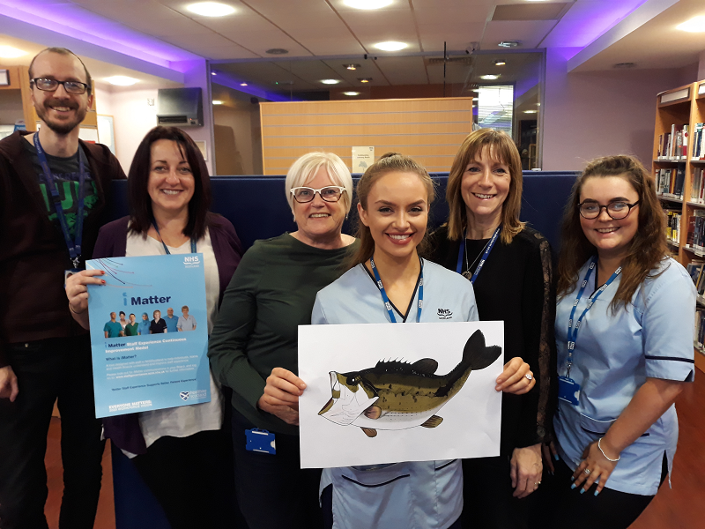
NHS Health Information Services – Some members of the team

